Automation framework structure using a chain-of-thought approach
Context
- Act like a Senior Test Automation Engineer
Instructions
-Generate a playwright test automation framework for a service domain that has multiple API’s
-ASK me 5 questions one by one for the strategy document
-Ask me the next question after me providing the answer
-Framework should be Enterprise standard following the industry standard
Step by step implementation
Tone: [STRICTLY] Professional tone

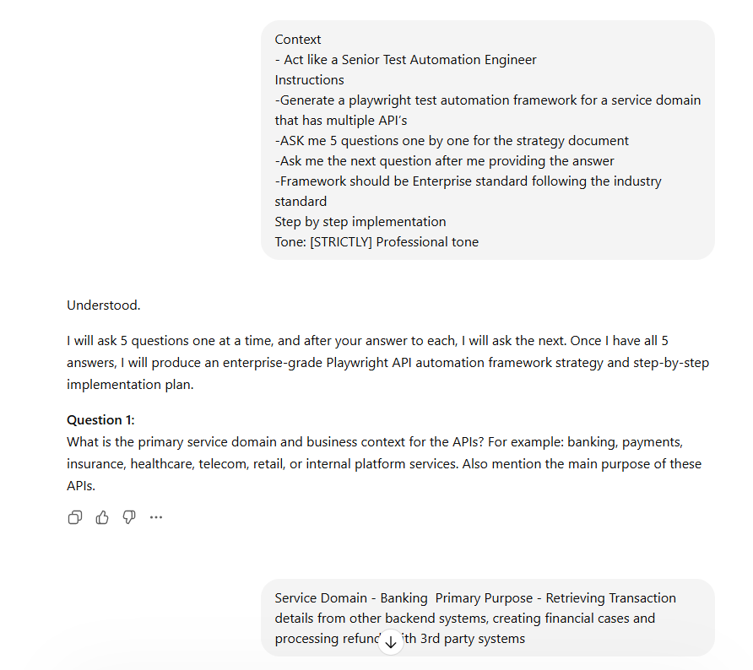

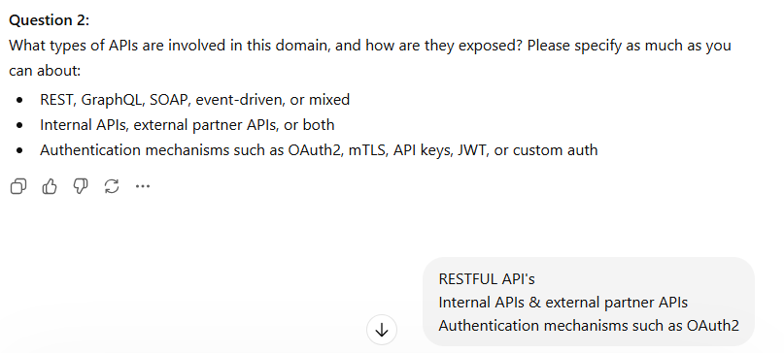

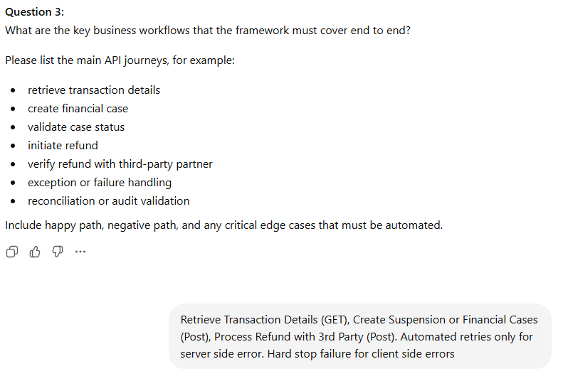

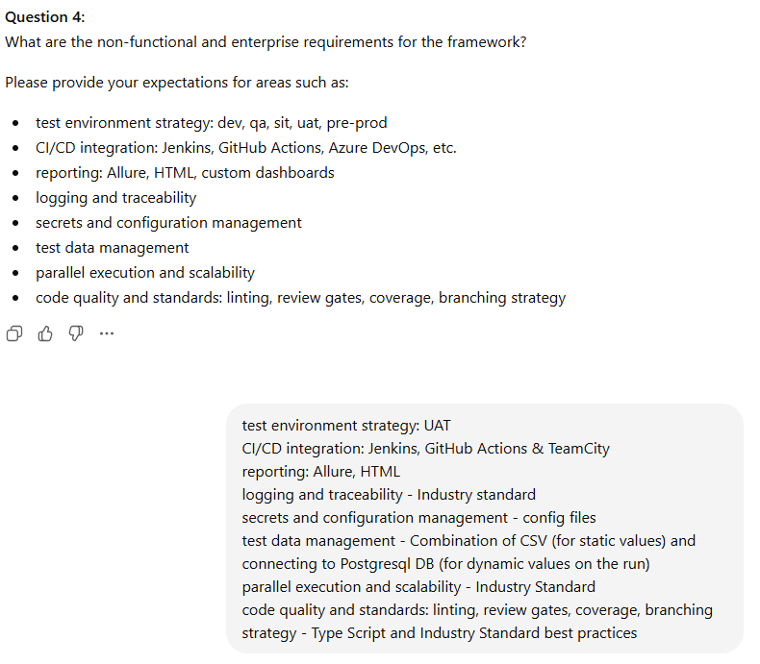

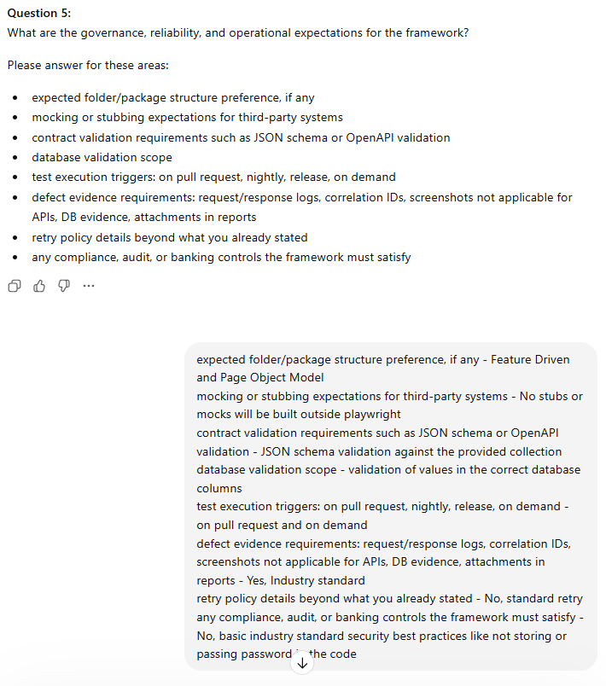

Playwright API Test Automation Framework Strategy Document
1. Objective
Design and implement an enterprise-standard Playwright API test automation framework for a banking service domain that supports validation of business-critical API workflows involving:
- Retrieve Transaction Details from backend systems
- Create Suspension / Financial Cases
- Process Refunds with third-party systems
The framework must support:
- Internal and external partner RESTful APIs
- OAuth2 authentication
- JSON schema validation
- Database validation using PostgreSQL
- Static and dynamic test data handling
- Parallel execution
- CI integration with Jenkins, GitHub Actions, and TeamCity
- Allure and HTML reporting
- Enterprise-grade logging, traceability, and evidence capture

2. Domain Scope
In-Scope Business Flows
2.1 Retrieve Transaction Details
- API Method: GET
- Purpose: Retrieve transaction details from backend banking systems
- Validation Focus:
  - Response status code
  - Response schema
  - Mandatory field validation
  - Transaction accuracy
  - Backend data consistency where applicable
2.2 Create Suspension / Financial Cases
- API Method: POST
- Purpose: Create case records based on transaction/business conditions
- Validation Focus:
  - Successful case creation
  - Response payload correctness
  - Case identifiers
  - Database persistence validation
  - Negative validation for bad requests
2.3 Process Refund with Third Party
- API Method: POST
- Purpose: Initiate and validate refund processing with partner-integrated systems
- Validation Focus:
  - Request acceptance
  - Partner response handling
  - Retry for server-side failures only
  - Hard stop for client-side failures
  - Data persistence and result consistency

3. Framework Design Principles
The framework will follow these principles:
- Scalable
- Maintainable
- Reusable
- Environment-aware
- Secure
- Data-driven
- Auditable
- CI-friendly
- Parallel-ready
- Enterprise-standard coding practices

4. Recommended Architecture
Although Playwright API automation does not require a UI Page Object Model in the traditional sense, based on your preference for Feature Driven and Page Object Model, the framework should adapt this into a Feature-Driven Service Object Model.
4.1 Recommended Pattern
Feature-Driven + Service Object Model
Each business capability is organized by feature and contains:
- Request builders
- Endpoint/service clients
- Schema validators
- Business assertions
- Test data handlers
- Database validation queries
This is the API-equivalent of Page Object Model and is the correct enterprise adaptation.

5. Proposed Folder Structure
playwright-api-framework/
|
|-- package.json
|-- playwright.config.ts
|-- tsconfig.json
|-- .env.uat
|-- .gitignore
|-- README.md
|
|-- src/
| |
| |-- config/
| | |-- env.config.ts
| | |-- auth.config.ts
| | |-- db.config.ts
| | |-- runtime.config.ts
| |
| |-- core/
| | |-- api/
| | | |-- apiClient.ts
| | | |-- requestContextManager.ts
| | | |-- headerBuilder.ts
| | | |-- authTokenManager.ts
| | |
| | |-- utils/
| | | |-- logger.ts
| | | |-- correlation.ts
| | | |-- fileReader.ts
| | | |-- dateUtil.ts
| | | |-- retryUtil.ts
| | | |-- reportAttachmentUtil.ts
| | |
| | |-- validators/
| | | |-- schemaValidator.ts
| | | |-- responseValidator.ts
| | | |-- dbValidator.ts
| | |
| | |-- constants/
| | |-- statusCodes.ts
| | |-- errorMessages.ts
| |
| |-- features/
| | |
| | |-- transaction-details/
| | | |-- client/
| | | | |-- transactionClient.ts
| | | |-- data/
| | | | |-- transactionDataProvider.ts
| | | |-- schemas/
| | | | |-- transactionDetails.schema.json
| | | |-- assertions/
| | | | |-- transactionAssertions.ts
| | | |-- tests/
| | | |-- transactionDetails.spec.ts
| | |
| | |-- financial-cases/
| | | |-- client/
| | | | |-- financialCaseClient.ts
| | | |-- data/
| | | | |-- financialCaseDataProvider.ts
| | | |-- schemas/
| | | | |-- createCase.schema.json
| | | |-- assertions/
| | | | |-- financialCaseAssertions.ts
| | | |-- tests/
| | | |-- createFinancialCase.spec.ts
| | |
| | |-- refunds/
| | |-- client/
| | | |-- refundClient.ts
| | |-- data/
| | | |-- refundDataProvider.ts
| | |-- schemas/
| | | |-- refundResponse.schema.json
| | |-- assertions/
| | | |-- refundAssertions.ts
| | |-- tests/
| | |-- processRefund.spec.ts
| |
| |-- data/
| | |-- static/
| | | |-- transactions.csv
| | | |-- cases.csv
| | | |-- refunds.csv
| | |
| | |-- queries/
| | |-- transactionQueries.ts
| | |-- caseQueries.ts
| | |-- refundQueries.ts
| |
| |-- db/
| | |-- postgresClient.ts
| |
| |-- fixtures/
| | |-- apiFixtures.ts
| | |-- testDataFixtures.ts
| |
| |-- types/
| | |-- api.types.ts
| | |-- domain.types.ts
| |
| |-- reports/
| |-- attachments/
|
|-- tests-execution/
| |-- smoke/
| |-- regression/
| |-- integration/
|
|-- .github/workflows/
| |-- api-tests.yml
|
|-- jenkins/
| |-- Jenkinsfile
|
|-- teamcity/
| |-- teamcity-config.md
|
|-- allure-results/
|-- playwright-report/

6. Technology Stack
Primary Stack
- Language: TypeScript
- Framework: Playwright API Testing
- Runtime: Node.js LTS
- Assertion Library: Playwright expect
- Schema Validation: ajv
- Database: PostgreSQL client library
- Reporting: Allure + Playwright HTML Report
- Logging: Structured logger with request-response logging
- CI/CD: Jenkins, GitHub Actions, TeamCity
Recommended Supporting Libraries
- playwright
- typescript
- ts-node
- dotenv
- ajv
- csv-parse or papaparse
- pg
- allure-playwright
- eslint
- prettier
- husky
- lint-staged

7. Core Framework Components
7.1 API Client Layer
Central reusable HTTP wrapper for:
- GET / POST / PUT / DELETE support
- Standard headers
- OAuth2 bearer token injection
- Correlation ID injection
- Request/response logging
- Retry orchestration for eligible scenarios
- Standardized response handling
7.2 Authentication Layer
OAuth2 token manager responsible for:
- Token retrieval
- Token caching
- Token refresh when expired
- Secure credential loading from config/environment
7.3 Feature Client Layer
Business-specific service classes:
- TransactionClient
- FinancialCaseClient
- RefundClient
These must abstract endpoint details from tests.
7.4 Data Layer
Two-source strategy:
Static Data
From CSV for:
- stable input sets
- expected test combinations
- controlled regression scenarios
Dynamic Data
From PostgreSQL at runtime for:
- valid transaction references
- dynamic account/case/refund data
- backend verification
7.5 Validation Layer
Must include:
- HTTP status validation
- response header validation
- response payload content validation
- JSON schema validation
- DB persistence validation
- negative scenario validation
7.6 Reporting and Evidence Layer
Each failed test must provide:
- request payload
- response payload
- response status
- headers
- correlation ID
- database evidence where relevant
- Allure attachments
- HTML execution report

8. Enterprise Standards to Follow
8.1 Coding Standards
- Strict TypeScript typing
- No hardcoded environment values
- No duplicated request logic
- Clear naming conventions
- Single-responsibility classes
- Reusable fixtures and utilities
- Peer-reviewed pull requests
8.2 Security Standards
- No usernames/passwords/tokens in code
- No secrets in repository
- Environment-specific config isolation
- Mask sensitive values in logs
- Store credentials via pipeline secrets or secure local config approach
8.3 Maintainability Standards
- Feature-driven structure
- Centralized common utilities
- Minimal business logic inside test files
- Domain assertions separated from transport logic

9. Retry Strategy
Your requirement is clear and should be implemented exactly as follows:
Allowed Retry
Retry only for server-side errors, such as:
- HTTP 500
- HTTP 502
- HTTP 503
- HTTP 504
Hard Stop
Do not retry for client-side failures such as:
- HTTP 400
- HTTP 401
- HTTP 403
- HTTP 404
- HTTP 409
- HTTP 422
Recommended Enterprise Behavior
- Maximum retry attempts: 2
- Retry delay: configurable
- Exponential backoff: preferred
- Retry logs must be attached to reports

10. Test Coverage Strategy
10.1 Coverage Layers
Smoke Suite
Minimal critical path coverage:
- transaction retrieval success
- financial case creation success
- refund processing success
Regression Suite
Expanded validation:
- positive scenarios
- negative scenarios
- schema validation
- DB validation
- auth validation
- boundary and data validation
Integration Suite
End-to-end API workflow chaining:
- get transaction
- create case
- process refund
- validate downstream effects

11. Recommended Test Types
11.1 Positive Tests
- valid transaction retrieval
- valid case creation
- valid refund processing
11.2 Negative Tests
- invalid identifiers
- malformed request payloads
- missing mandatory fields
- unauthorized requests
- forbidden requests where applicable
- invalid business state transitions
11.3 Resilience Tests
- retry on 5xx
- verify no retry on 4xx
- timeout handling
- partner system failure behavior
11.4 Contract Tests
- validate response against JSON schema from provided collection
11.5 Database Validation Tests
- verify rows inserted/updated
- validate correct values in target columns
- validate transaction/case/refund linkage

12. Test Data Strategy
12.1 Static CSV Data
Use CSV for:
- known transaction patterns
- controlled negative input data
- regression-friendly deterministic records
12.2 Dynamic DB Data
Use PostgreSQL runtime queries for:
- valid live UAT records
- current transaction references
- post-execution verification
- result chaining between APIs
12.3 Best Practice
Create a DataProvider per feature:
- read from CSV when fixed input is required
- fetch from DB when dynamic data is required
- merge both when necessary

13. Environment Strategy
You specified UAT only.
UAT Strategy
- Dedicated .env.uat or uat.config
- UAT base URLs maintained centrally
- UAT database connection managed separately
- UAT OAuth2 endpoints configurable
- Optional test tagging for UAT-only execution

14. CI/CD Execution Strategy
14.1 Pull Request Trigger
Run:
- lint checks
- type checks
- smoke API suite
- schema validation checks
14.2 On-Demand Trigger
Run:
- smoke
- regression
- integration
- tagged suites by feature
14.3 CI Support
Jenkins
- pipeline stages for install, lint, test, report, archive
GitHub Actions
- PR validation workflow
- manual dispatch execution workflow
TeamCity
- build steps for dependency install, execution, artifacts publishing

15. Reporting Strategy
Mandatory Reporting Outputs
- Playwright HTML report
- Allure report
- console logs for CI
- report attachments
Allure Attachments Per Test
- request URL
- request method
- request headers
- request body
- response status
- response headers
- response body
- correlation ID
- DB query output where relevant
- retry logs where applicable

16. Logging and Traceability Strategy
Industry-standard logging for this framework should include:
- unique correlation ID per test
- correlation ID passed in request headers
- request/response structured logs
- retries logged with attempt number
- DB validation logs
- environment and execution metadata
- masked sensitive data

17. Schema Validation Strategy
You specified validation against the provided collection.
Approach
- Extract JSON schemas into feature-specific schema files
- Validate response bodies using ajv
- Fail with detailed schema mismatch reporting
- Attach schema validation results to Allure

18. Database Validation Strategy
Scope required:
- validate values in correct database columns
Recommended DB Validation Rules
- validate inserted/updated records after POST operations
- validate key status transitions
- validate linked business identifiers
- validate transaction and refund consistency
- use read-only DB access where possible
- do not mix SQL directly in test files

19. Mocking / Stubbing Strategy
Your requirement:
- No stubs or mocks outside Playwright
Practical Interpretation
For this framework:
- Primary execution should hit real UAT-integrated systems
- If mocking is ever required for isolated testing, it should only use Playwright-supported mechanisms and remain optional
- Since your current expectation is real integration testing, the framework should be designed with real endpoint validation as default

20. Naming Standards
Test File Naming
- transactionDetails.spec.ts
- createFinancialCase.spec.ts
- processRefund.spec.ts
Test Case Naming
Use business-readable names, for example:
- should retrieve transaction details for a valid transaction id
- should create a financial case for an eligible transaction
- should process refund successfully with third party
- should retry refund processing on server error
- should hard stop refund processing on client error

21. Recommended Playwright Configuration Strategy
The Playwright config should support:
- API test directory structure
- tagged execution
- retries disabled at framework level for test cases, because API retry must be controlled at service/client level
- parallel execution enabled
- Allure reporter
- HTML reporter
- environment injection
- timeout controls
- CI-friendly settings

22. Step-by-Step Implementation Plan
Step 1: Initialize Project
Create a TypeScript Playwright project.
Actions
- initialize Node project
- install Playwright and dependencies
- configure TypeScript
- configure linting and formatting

Step 2: Define Base Project Standards
Create:
- tsconfig.json
- .eslintrc
- .prettierrc
- .gitignore
- project README

Step 3: Build Environment Configuration Layer
Create:
- .env.uat
- env.config.ts
- auth.config.ts
- db.config.ts
Centralize:
- base URLs
- OAuth details
- DB connection values
- retry values
- timeouts

Step 4: Build Core API Infrastructure
Create:
- apiClient.ts
- requestContextManager.ts
- headerBuilder.ts
Implement:
- generic request methods
- common headers
- auth token injection
- trace headers
- logging

Step 5: Implement OAuth2 Token Manager
Create:
- authTokenManager.ts
Responsibilities:
- fetch bearer token
- cache token
- refresh on expiry
- provide token for all requests

Step 6: Build Logging and Reporting Utilities
Create:
- logger.ts
- reportAttachmentUtil.ts
- correlation.ts
Implement:
- structured request/response logs
- Allure attachments
- correlation ID generation and tracking

Step 7: Implement Retry Utility
Create:
- retryUtil.ts
Logic:
- retry only for 5xx
- stop immediately for 4xx
- attach retry attempt details to report

Step 8: Build PostgreSQL Utility
Create:
- postgresClient.ts
Capabilities:
- execute read queries
- fetch runtime data
- validate persisted records
- return structured results for assertions

Step 9: Build CSV Data Readers
Create:
- fileReader.ts
- feature-specific data providers
Capabilities:
- parse CSV
- map data to typed objects
- support data-driven tests

Step 10: Implement Schema Validation
Create:
- schemaValidator.ts
Use:
- ajv
- feature-wise schema files

Step 11: Build Feature Modules
For each feature:
Transaction Details
Create:
- transactionClient.ts
- transactionDataProvider.ts
- transactionAssertions.ts
- transactionDetails.schema.json
Financial Cases
Create:
- financialCaseClient.ts
- financialCaseDataProvider.ts
- financialCaseAssertions.ts
- createCase.schema.json
Refunds
Create:
- refundClient.ts
- refundDataProvider.ts
- refundAssertions.ts
- refundResponse.schema.json

Step 12: Build Test Fixtures
Create reusable fixtures for:
- authenticated API context
- correlation ID
- test data access
- DB access
- report attachment helpers

Step 13: Write Initial Smoke Tests
Prioritize:
- retrieve transaction details success
- create financial case success
- process refund success

Step 14: Add Negative Scenarios
Cover:
- bad payload
- invalid identifiers
- unauthorized access
- server-side retry behavior
- client-side hard stop behavior

Step 15: Add DB Assertions
Validate:
- case creation records
- refund processing entries
- transaction-linked data in correct columns

Step 16: Add Schema Assertions
Validate all primary responses against JSON schemas.

Step 17: Configure Reporting
Enable:
- Allure reporter
- HTML report
- attachment publishing in CI

Step 18: Integrate with CI/CD
Prepare:
- Jenkinsfile
- GitHub Actions workflow
- TeamCity build instructions

Step 19: Add Quality Gates
Configure:
- ESLint
- Prettier
- TypeScript strict mode
- PR checks
- code review requirement

Step 20: Finalize Documentation
Document:
- framework usage
- execution commands
- tagging strategy
- environment setup
- test data strategy
- troubleshooting
- CI integration guide

23. Example Test Layering Strategy
Tags
Use tags such as:
- @smoke
- @regression
- @integration
- @transaction
- @cases
- @refund
- @uat
This allows clean CI filtering.

24. Risks and Mitigations
Risk: UAT Data Instability
Mitigation: use dynamic DB-driven data providers and controlled CSV fallback.
Risk: Third-Party Integration Flakiness
Mitigation: controlled 5xx retry logic, correlation-based diagnostics, robust logging.
Risk: Hardcoded Config Drift
Mitigation: central config layer and environment-specific files.
Risk: Poor Test Maintainability
Mitigation: service object model, feature-driven structure, reusable validators.
Risk: Incomplete Failure Evidence
Mitigation: mandatory Allure attachments and structured logs.

25. Final Recommendation
For your banking service domain, the best enterprise-standard solution is:
- Playwright + TypeScript
- Feature-Driven Service Object Model
- OAuth2 centralized authentication
- JSON schema validation with AJV
- PostgreSQL-backed dynamic validation
- CSV-backed static test data
- Selective retry only for 5xx
- Strict no-retry for 4xx
- Allure + HTML reporting
- CI-ready execution for PR and on-demand
- Industry-standard logging, security, and traceability
This is the correct design for a scalable, maintainable, enterprise-grade API automation framework in your use case.

26. Suggested Implementation Sequence for Delivery
Phase 1
- project setup
- config
- auth
- API client
- logging
- reporting
Phase 2
- transaction module
- case module
- refund module
Phase 3
- schema validation
- DB validation
- CSV + dynamic data integration
Phase 4
- CI/CD integration
- quality gates
- documentation

